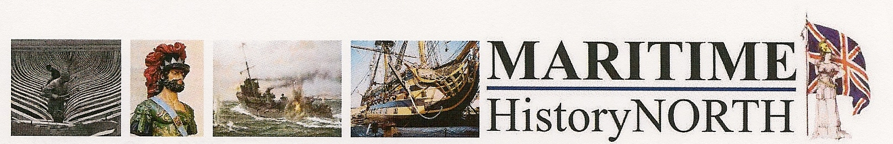
Spring 2024 Conference:
Fishing –The Men (and Women) and The Boats
We are back in Hull this March for what promises to be a fascinating day focussing on the important and dangerous business of Fishing. From the early days of the last century to the current time, developments and drama and the impact of this often-overlooked industry, locally, nationally and globally.
Tuesday 26th March 2024
The Nordic House / Danish Church, 104 Osborne Street, Hull HU1 2PN
Join us from 1000 for tea/coffee and registration
1030 – Welcome
Alison A Telfer RD
Fishermen, Fishing Vessels and the Great War at Sea
Dr Robb Robinson
The Headscarf Revolutionaries
Ian Cuthbert and Cllr Tracey Henry
Lunch
The Legal After Effects of the Headscarf Revolution
Andrew Oliver LLB
Why Fishing Matters
Captain David Carter MNM
Thanks and Au Revoir
Alison A Telfer RD
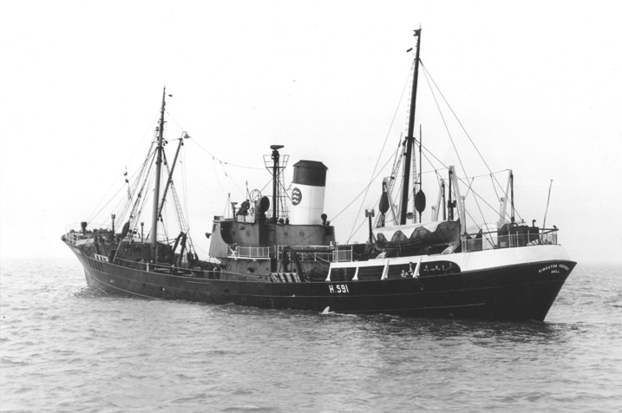
The Ticket Application forms are attached.

